Ownership Certificate

To Whom It May Concern

This is to certify that the following equipment mentioned below are the sole owned by
Branch of Sudhir Gensets LTD.

Equipment | Articulated Boom Lift
Brand / Make | Genie
Asset ID | S20SG-280
Model Number | Z62/40
Serial Number | Z62D-316
Working Height | 20 Meters
Year of Manufacturing | 2018

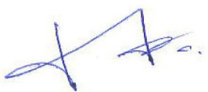
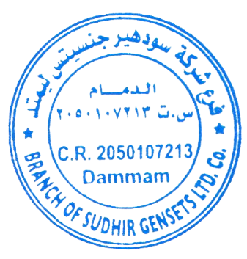
Mansoor Ali
Branch Manager
Branch of Sudhir Gensets LTD. Co
Dammam - KSA

